Aim:

Design a LCD interface programmable digital data display system .

Circuit Diagram:

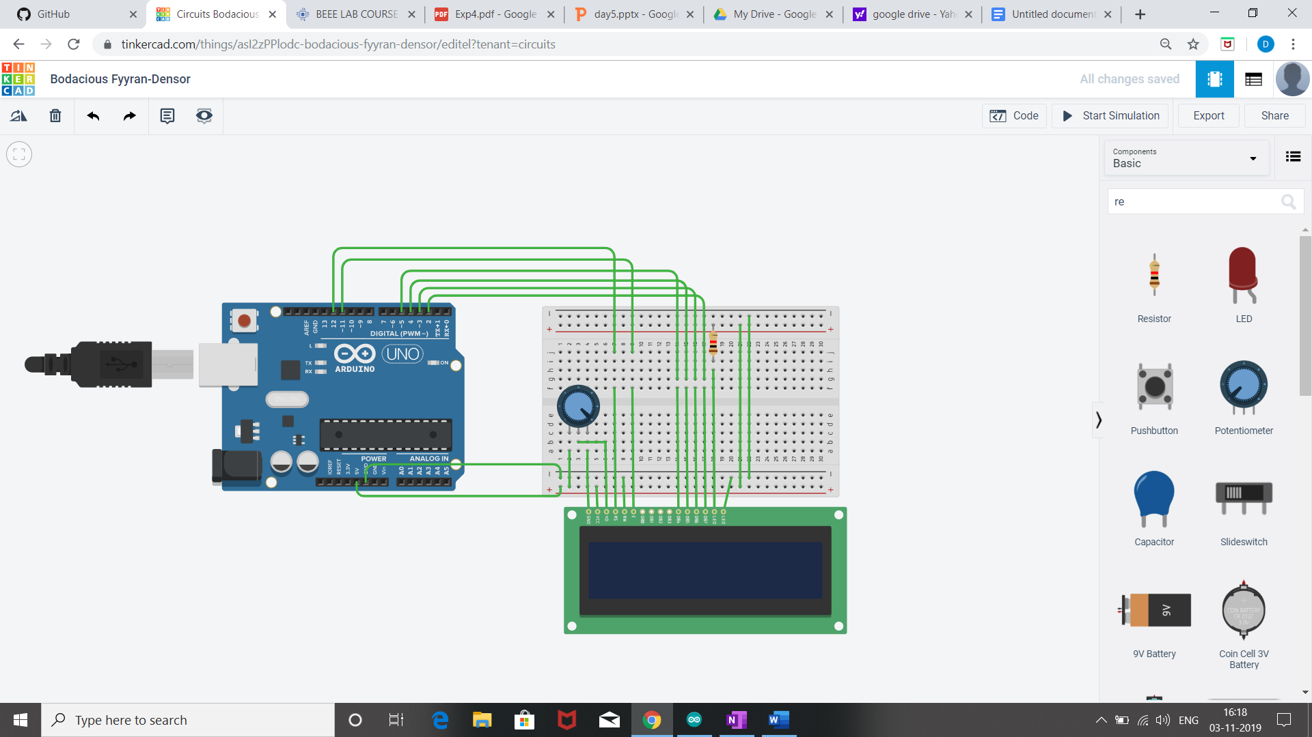

Theory :

LED is a light emmiting diode that gives light as a output. It is a semiconductor. They require very less power to get lighted and work very efficiently.

Arduino:
An Arduino UNO is a device that is equipped with digital and analog input/output slots. It has 14 Input/Output slots, 5 Analog slots and can work between 7 to 20 volts.It has 3 ground pins. It works when user inputs code into arduino.

Concept Used :

- We have used the concept of LCD(liquid crystal display).
- A register select (RS) pin that controls where in the LCD's memory you're writing data to. You can select either the data register, which holds what goes on the screen, or an instruction register, which is where the LCD's controller looks for instructions on what to do next.
- A Read/Write (R/W) pin that selects reading mode or writing mode
- An Enable pin that enables writing to the registers
- 8 data pins (D0 -D7). The states of these pins (high or low) are the bits that you're writing to a register when you write, or the values you're reading when you read.
- There's also a display constrast pin (Vo), power supply pins (+5V and Gnd) and LED Backlight pins that you can use to power the LCD, control the display contrast, and turn on and off the LED backlight, respectively
- We have used the potentiometer for variable resistance.
- Learning and observation:
- The Liquid Crystal library works with all LCD displays that are compatible with the driver.
- Potentiometer keeps voltage difference constant.
- A digital data display of hello world can be seen when you turn on the circuit.
- A in-built library #include <LiquidCrystal.h> is used to reduce the code which already contain the details of connections.

Observation :
LCD displays what is written in programme .
Learning Outcomes:

- Learned about the different components in an Arduino.
- Learned how to connect the wires in an Arduino, and breadboard and writing the program.
- Learned how a Ultrasonic Sensor works and its connections with Arduino using breadboard.

Problems :

- Connections of LED may not be connected properly.
- LED's may not be working.
- Code may be wrong
- Arduino is not working.

Troubleshooting:

- All connections should be checked properly.
- Arduino should be working.
- LED's that are in working conditions should be used.
- Right code must be used.

Precaution:

- Don't plug in an LED without a current limiting resistor.
- Don't supply more than 9V unless proper knowledge.
- Check all the connections.

Code:
/*
LiquidCrystal Library - Hello World

Demonstrates the use a 16x2 LCD display. The LiquidCrystal
library works with all LCD displays that are compatible with the
Hitachi HD44780 driver. There are many of them out there, and you
can usually tell them by the 16-pin interface.

This sketch prints "Hello World!" to the LCD
and shows the time.

The circuit:
* LCD RS pin to digital pin 12
* LCD Enable pin to digital pin 11
* LCD D4 pin to digital pin 5
* LCD D5 pin to digital pin 4
* LCD D6 pin to digital pin 3
* LCD D7 pin to digital pin 2
* LCD R/W pin to ground
* LCD VSS pin to ground
* LCD VCC pin to 5V
* 10K resistor:
* ends to +5V and ground
* wiper to LCD VO pin (pin 3)

Library originally added 18 Apr 2008
by David A. Mellis
library modified 5 Jul 2009
by Limor Fried (http://www.ladyada.net)
example added 9 Jul 2009
by Tom Igoe
modified 22 Nov 2010
by Tom Igoe
modified 7 Nov 2016
by Arturo Guadalupi

This example code is in the public domain.

http://www.arduino.cc/en/Tutorial/LiquidCrystalHelloWorld

*/

// include the library code:
#include <LiquidCrystal.h>

// initialize the library by associating any needed LCD interface pin
// with the arduino pin number it is connected to
const int rs = 12, en = 11, d4 = 5, d5 = 4, d6 = 3, d7 = 2;
LiquidCrystal lcd(rs, en, d4, d5, d6, d7);

void setup() {
// set up the LCD's number of columns and rows:
lcd.begin(16, 2);
// Print a message to the LCD.
lcd.print("hello, world!");
}

void loop() {
// set the cursor to column 0, line 1
// (note: line 1 is the second row, since counting begins with 0):
lcd.setCursor(0, 1);
// print the number of seconds since reset:
lcd.print(millis() / 1000);
}

